MAJORETTE SPORT WORLD FEDERATION
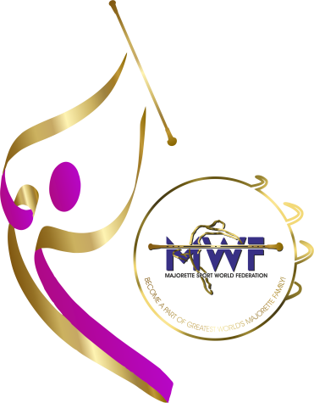
CONFERENCE
FOR COACHES
BU0DAPEST-HU/29.-30.11.2025.
Deadline/30.10.2025.
REGISTRATION FORM

E-mail: mwfeducation1@gmail.com
NAME AND SURNAME:
DATE OF BIRTH:
NATIONAL ASSOCIATION:
TEAM:
YEARS OF WORKING IN THE TEAM:
ADRESS:
MOBILE NUMBER:
E-MAIL:
ACCOMODATION:
- Single room / name
- Double room /name
DATE -ACCOMODATION:
a)29.-30.11.2025.
b)28.-30.11.2025.
c) ….your date___

ENTRY FEE: includes a coffee break and all materials related to the seminar
70.00 EUR /invoice for the entry fee will be sent after registration
CERTIFICATE for all participants.
DEADLINE REGISTRATION: 30.10.2025. E-mail: mwfeducation1@gmail.com



