MAJORETTE-SPORT WORLD FEDERATION
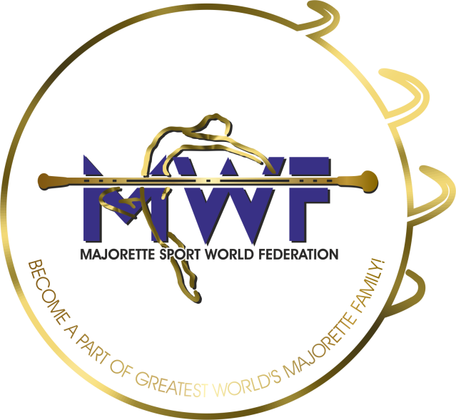

MWF meetings
PRAGUE-CZ/09.-11.10.2026.
APPLICATION FORM
DEADLINE – 20.09.2026.
E-mail: mwf.majorettes1@gmail.com / judicalcommitee.mwf1@gmail.com

ONLINE
MANAGEMENT BOARD
JUDICIAL COMMITTEE
COMMITTEE FOR EDUCATION
SEMINAR AND EXAM FOR INTERNATIONAL JUDGES/new canidates
COMPETITORS COMMITTEE

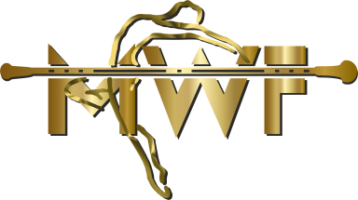
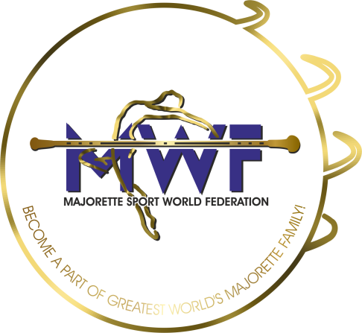

MWF-meetings
PRAGUE-CZ/09.-11.2026. 19.01.2020. PARTICIPANTS:
Organization:
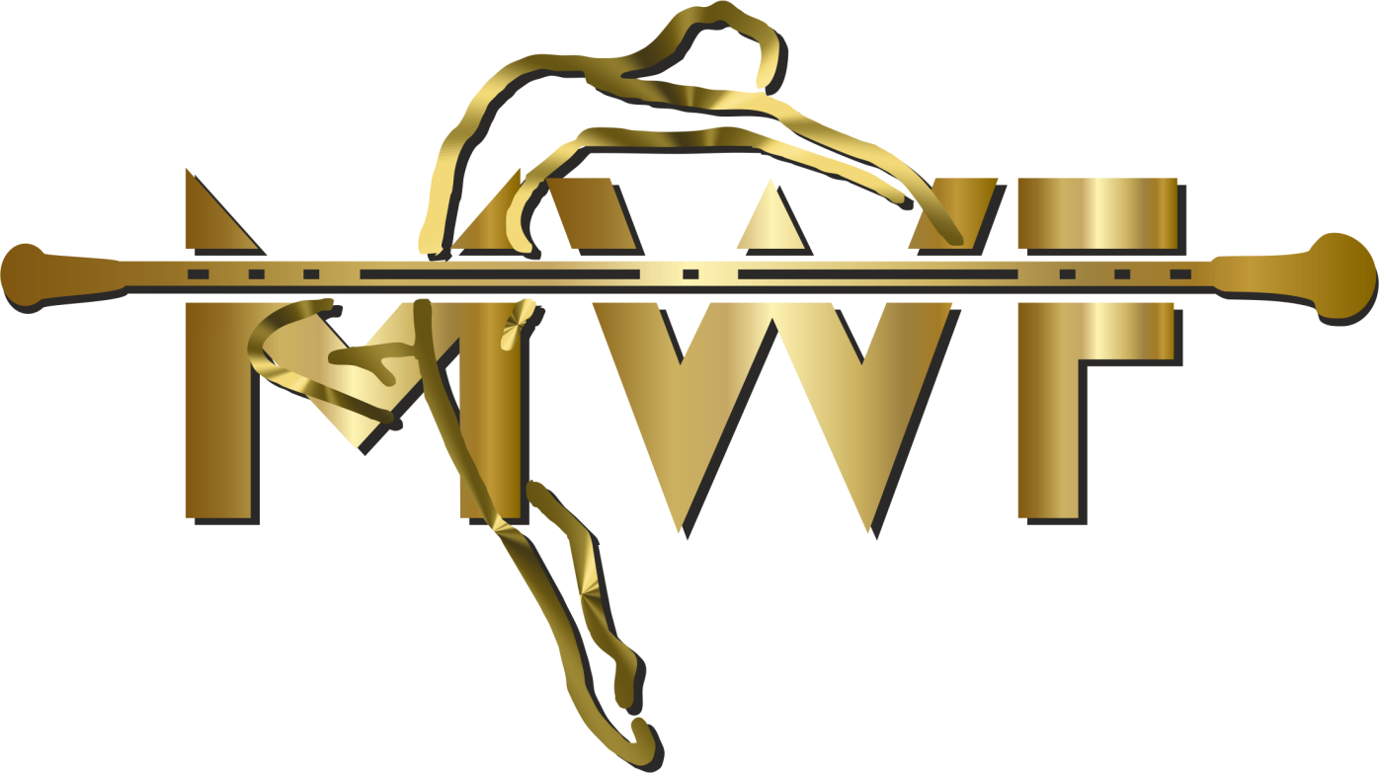
Country:
Name-function:
E-mail/phone:
ADRESS:
Arriving on:
Date:
Signature:

