MAJORETTE SPORT WORLD FEDERATION
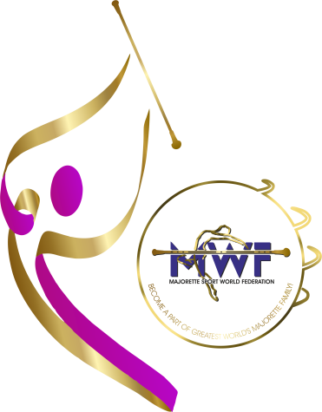
SEMINAR
FOR INTERNATIONAL COACHES
BUDAPEST-HUNGARY
13.-15.03.2026.

REGISTRATION FORM
Deadline /20.02.2026.

E-mail: mwfeducation1@gmail.com
NAME AND SURNAME:
DATE OF BIRTH:
NATIONAL ASSOCIATION:
TEAM:
YEARS OF WORKING IN THE TEAM:
ADRESS:
MOBILE NUMBER:
E-MAIL:
RESPONSIBLE PERSON:
MOBILE NUMBER:
E-MAIL:


0

